

on behalf of Rondesere Ltd.

for the Proposed Development at Grange Road, Baldoyle, Dublin 13

LANDSCAPE AND
VISUAL IMPACT ASSESSMENT

Grange Road, Baldoyle, Dublin 13 December 2023

Landscape and Visual Impact Assessment

Table of Contents
1.0 Introduction 4
1.1 Statement of Authority 5
2.0 Relevant Legislation, Planning Policies and Guidance 6
3.0 Methodology 7
3.1 Nature of Impacts 8
4.0 The Receiving Environment 10
4.1 Description 10
5.0 Summary of Landscape Characteristics and Values 11
5.1 Landscape Values 11
5.2 Conservation Values 12
5.3 Enhancement Values 12
6.0 Characteristics of the Proposed Development 14
7.0 Assessment of Potential Impacts 15
7.1 Do Nothing Impact 15
7.2 Potential Visual Impact of the Proposed Development 16
7.2.1 Assessment of the Construction Impacts 16
7.2.2 Assessment of the Operational Impacts 18
7.3 Mitigation Measures 19
7.3.1 Construction Phase 20
7.3.2 Operational Phase 21
7.4 Residual Impacts 23
7.5 Cumulative Impacts 23
7.5.1 Construction Visual Impact 25
7.5.2 Construction Landscape Impact 25
7.5.3 Operational Visual Impact 26
8.0 Landscape Impact Assessment Criteria 28
9.0 Visual Selector Interaction 31
9.1 Sensitivity – susceptibility of receptors 31
9.2 Images and Photomontages 32
10.0 VIA Viewpoints 32
11.0 Difficulties Encountered in Compiling 42
12.0 Conclusion 42
13.0 References 44

1.0 Introduction
RMDA Landscape Architects have been retained by Rondesere Ltd. to prepare this Landscape and Visual Impact Assessment (LVIA) for the consideration of Fingal County Council in respect of the proposed LRD development consisting of 120 no. units located on lands at Grange Road, Baldoyle, Dublin 13. The proposed development consist of the following;
1. Demolition of existing, single storey, storage structures on the subject site (c. 446.5 m2 GFA).
2. The construction of a residential development (c. 15, 234.11 m2 GFA) comprising of 120 no. apartment units (15 no. studio units, 18 no. 1 bed units, 78 no. 2 bed units, 7 no. 3 bed units, 2 no. 4 bed penthouse units) within 1 no. block (ranging in height from 4 - 12 storeys over basement level).
3. The construction of a basement to be accessed off Myrtle Road with provision of c. 47 no. car parking spaces, including accessible spaces, electric vehicle charging points and residential visitor parking.
4. Addition of 2 no. crèche drop off car parking spaces at surface level.
5. Provision of 360 no. ‘long stay’ residential bicycle parking spaces at basement level together with additional 60 no. visitor bicycle parking spaces in secure locations at surface level.
6. All apartments are provided with private terraces / balconies.
7. Provision of c. 1877 m2 of open space to serve the development including green roof garden terraces between 5th and 10th floor level.
8. Provision of a childcare facility at ground floor level (c. 156.6 m2 GFA) with capacity in the order of 35 no. children and associated, secure, open play area (c. 117.1 m2).
9. Provision of Café unit (c. 70 m2 GFA) at ground floor level with associated outdoor seating area.
10. Provision of associated gymnasium at ground and first floor level (c. 273.12 m2).
11. Provision of Multipurpose Room (c. 48 m2 GFA) and Residents Lounge (c. 20 m2) at first floor level.
12. Total non-residential use is c. 567.72 m2 (3.73 % of overall development).
13. The development will also provide for all associated ancillary site development infrastructure including: ESB sub-station, bike stores, bin stores, plant rooms, public lighting, new watermain connection and foul and surface water drainage; internal roads & footpaths; site landscaping, including boundary treatments; associated scheme signage, and all associated site development and excavation works above and below ground necessary to facilitate the development.

This report identifies and assesses the potential effects of the proposed Large – Scale Residential Development at Grange Road, Baldoyle, Dublin 13 on the landscape and visual resource of the study area. It examines the proposed mitigation and compensation measures that will be implemented to prevent, reduce, or offset potential adverse landscape and visual effects or enhance potential beneficial effects.
The report considers how:
- Landscape effects associated with a development relate to changes to the fabric, character, and quality of the landscape resource and how it is experienced.
- Visual effects relate closely to landscape effects, but also concern changes in views as visual assessment is also concerned with people’s perception and response to changes in visual amenity.

Landscape and visual effects are interrelated with other environmental effects but are assessed separately. Whilst elements of the built heritage such as Listed Buildings and Conservation Areas are important elements of the landscape and contribute to its character and influence its quality and value, effects on the significance of these designated features and their setting do not form part of this assessment.
The landscape and visual impact assessment is supported by a booklet of photomontages (prepared by Digital Dimensions), which is included as a separate document in the planning application.

1.1 Statement of Authority
RMDA provides specialist landscape and visual services for projects from inception, through site/route selection, environmental impact assessment (EIA) and the planning process, to detailed design and construction. The company specialises in landscape character assessment (LCA) and landscape and visual impact assessment (LVIA) – for a wide variety of projects.
Ronan MacDiarmada is the chapter’s main author, and Peter Lynch provided oversight and review. Ronan MacDiarmada, B.Agr. Sc. (Land. Hort.) is the director of Ronan MacDiarmada & Associates Ltd and is graduate of University College Dublin. He is a qualified Landscape Architect and a Corporate Member of the Irish Landscape Institute. He has specialised in Landscape and Visual Assessment (LVIA) and has over twenty years’ experience in a range of projects, from large scale strategic design, master planning and detailed design to LVIA and landscape planning, including Strategic Housing Developments throughout Ireland.

2.0 Relevant Legislation, Planning Policies and Guidance
European
The European Landscape Convention provides guidelines for managing landscapes. The Convention is not an EU Directive. Countries that sign and ratify the Convention make a commitment to upholding the principles it contains within the context of their own domestic legal and policy frameworks. The convention was ratified by Ireland in March 2002 and came into effects in Ireland in 2004. The European Landscape Convention requires “landscape to be integrated into regional and town planning policies and in cultural, environmental, agricultural, social and economic policies, as well as any other policies with possible direct or indirect impacts on Landscape”.

National
The National Landscape Strategy (NLS) for Ireland 2015-2025 was launched in May 2015 and is to be implemented by the Government in the future. The NLS promotes the sustainable protection, management, and planning for the landscape. The NLS states that the “National Landscape Strategy will be used to ensure compliance with the European Landscape Convention and to establish principles for protecting and enhancing the landscape while positively managing its change. It will provide a high-level policy framework to achieve balance between the protection, management and planning of the landscape by way of supporting actions.” It also states that “The Strategy sets out Ireland’s high-level objectives and actions with regard to landscape. It also positions landscape in the context of existing Irish and European strategies, policies and objectives, and outlines methods of ensuring co-operation at a sectoral and at a European level by the State.”

Urban Development and Building Heights – Guidelines for Planning Authorities, December 2018

These guidelines set out national planning policy guidance on building heights with regard to urban areas. Under the guidance, it is considered that by consolidating and strengthening existing built up areas, more sustainable development patterns can be achieved by limiting the expansion of towns and cities outwards. These guidelines build upon the strategic policy framework set out in Project Ireland 2040 and the National Planning Framework. With regard to the building heights of new developments, relevant aspects of these guidelines are extracted and listed as follows:

- Increased building height is a significant component in making optimal use of the capacity of sites in urban locations where transport, employment, services or retail development can achieve a requisite level of intensity for sustainability,
- Taller buildings can assist in reinforcing and contributing to a sense of place within a city or town centre,
- In some cases, statutory development plans have tended to set out overly restrictive maximum height limits in certain locations and crucially without the proper consideration of the wider planning potential of development sites.
Local Authorities and An Bord Pleanála “will be required to have regard to the guidelines and apply any specific planning policy requirements (SPPRs) of the guidelines … in carrying out their functions”. It should be highlighted that any SPPRs within the guidelines will take precedence over “any conflicting, policies and objectives of development plans, local area plans and strategic development zone planning schemes”.

Fingal Development Plan 2023 - 2029 (FDP)
The FDP is the main strategic planning policy document guiding the future renewal and development of Fingal to 2023 and beyond. Relevant details on planning policies are described in the Statement of Consistency report included in the planning submission package. Fingal Development Plan identifies and describes Landscape Character Areas (LCA) which provides for the classification of Fingal’s landscapes into the following (1) Types and Values and (2) Sensitivities. There are no protected views or structures, nor monuments or sites recorded on the subject site.

3.0 Methodology
This section sets out the methodology for the Landscape and Visual Impact Assessment (LVIA) as a result of the Proposed Development.

The following sources and guidelines were used in the assessment:
- ‘Guidelines for Landscape and Visual Impact Assessment’ (GLVIA), 3rd Edition, 2013, Landscape Institute (UK) & IEMA
- ‘Visual Representation of Development Proposals’, Landscape Institute, Technical Guidance Note 06/19, 17 September 2019
- Fingal County Development Plan 2017-2023
- National Parks and Wildlife Service (NPWS), http://www.npws.ie/
The following Methodology was used in this assessment:
- A desk top study of the proposed site and its environs, including reviewing aerial photography and ordinance survey documents.
- A site survey was undertaken to determine the character of the landscape and the surrounding area, including site visits.
- An assessment of the proposed development was carried out by examining the layout plans, elevations, and sections to determine the impacts of the development.
- An evaluation of these impacts was carried out in accordance with the criteria set out in the EPA guidelines.
- A review of statutory planning and other documentation in order to ascertain the local and wider significance.
- RMDA were involved in the landscape design of the proposed development and liaised directly with the arborist, ecologist and the design team for the project. The design was heavily influenced by the retention of existing trees and the planting of native hedges, trees and pollinator planting.
- Photomontages were prepared by Digital Dimensions and the review and assessment to determine the visual impact and effect on the Landscape was carried out by RMDA.

3.1 Nature of Impacts
Impact on landscape arising from development has two distinct but closely related aspects. The first is impact relates to the insertion of the proposed development into the existing context. The second aspect is the visual impact which depends on the degree and nature of change in the visual environment. It is recognised that the combined impact on character and views will draw responses, the significance of which will be partly informed by an individual’s subjective perception of how much the changes matter.

The assessment of landscape and visual impacts include:

- Direct impacts upon specific landscape elements and buildings within and adjacent to the site.
- Effects on the overall pattern of the landscape elements that give rise to the character of the site and its surroundings.
- Impacts upon any special features or interests in or around the site.
- Direct impacts of the scheme upon views in the landscape.
- Overall impact on landscape character and visual amenity.

In determining the Visual Impacts, the following definitions were used to assess the significance of the impacts:

Impact Significance Criteria

- No Impact: There are no changes to views in the visual landscape.
- Imperceptible Impact: An impact capable of measurement but without noticeable consequences.
- Slight Impact: An impact which causes noticeable changes in the character of the environment without affecting its sensitivities.
- Moderate Impact: An impact that alters the character of the environment in a manner that is consistent with existing and emerging trends.
- Significant Impact: An impact which, by its character, magnitude, duration, or intensity alters a sensitive aspect of the environment.
- Profound Impact: An impact which obliterates sensitive characteristics.

Terms used to describe Quality of Visual Impact:

- Neutral Impact: A change which does not affect the quality of the landscape.
- Positive Impact: A change which improves the quality of the environment or landscape.
- Negative Impact: A change which reduces the quality of the environment or landscape.

Terms used to describe the Duration of Visual Impact

▪ | Momentary Effects | Seconds to Minutes
▪ | Brief Effects | Less than a day
▪ | Temporary Effects | Less than a year
▪ | Short-term Effects | Lasting 1 to 7 years
▪ | Medium-term Effects | Lasting 7 to 15 years
▪ | Long-term Effects | Lasting 15 to 60 years
▪ | Permanent Effects | Lasting over 60 years
▪ | Reversible Effects | Effects that can be undone
▪ | Frequency of Effects | Describe how often the effect will occur

4.0 The Receiving Environment

4.1 Description
The subject site extends to approx. 0.45 hectares and is located on lands at Grange Road, Baldoyle, Dublin 13.
The site is bounded to the north by an existing residential development (Myrtle Rod), by Grange Road to the south separating the subject site with Baldoyle Industrial Estate, by Longfield Road and Beshoff Motors Car Dealers to the east and an educational facility currently under construction on lands adjoining the west of the subject site.
The subject site is located in close proximity to Clongriffin Station, a high frequency public railway station providing direct and seamless connectivity to Dublin’s City Centre and to the wider Dublin area. In addition, the site benefits from being serviced with high frequency public bus network services infrastructure. Please refer to Waterman Moylan’s Engineering Assessment Report for further information.

6.0 Characteristics of the Proposed Development
Planning permission is being sought for a Large - Scale Residential Development (LRD) application on behalf of Rondesere Ltd. which consists of 120 no. residential units at Grange Road, Baldoyle, Dublin 13. The proposed development will consist of 15 no. studio units, 18 no. 1 bed units, 78 no. 2 bed units, 7 no. 3 bed units, 2 no. 4 bed penthouse units within 1 no. block ranging in height from 4 - 12 storeys over basement level. Additional uses including a crèche, Gym facility, Lounge, Multipurpose Room and café are proposed as part of the development.
The proposed development also consists of the construction of a basement car park to be accessed off Myrtle Road with provision of c. 47 no. car parking spaces, including accessible spaces, electric vehicle charging points and residential visitor parking with the addition of 2 no. crèche drop off car parking spaces at surface level. In addition, it is proposed to provide 360 no. ‘long stay’ residential bicycle parking spaces at basement level together with additional 60 no. visitor bicycle parking spaces in secure locations at surface level.
A high standard of landscaping works are proposed throughout the scheme which compliments the proposed development visually. For the purposes of calculating public open space requirements, it is noted that the area of the subject site is c. 4533.2 m2 (0.45 Hectares/ 1.12 Acres). 12 % of this site area equates to 544 m2. The proposed apartment development is subject to the ‘Sustainable Urban Housing: Design Standards for New Apartments Guidelines for Planning Authorities, 2020’, for the purposes of calculating a separate communal open space requirement. Having regard to the requirements of Appendix 1 of the above – mentioned Guidelines, the proposed 120 no. unit development (15 no. studio units, 18 no. 1 bed units, 78 no. 2 bed units, 7 no. 3 bed units, 2 no. 4 bed penthouse units) generates a communal open space requirement of 720 m2 to serve future residents. The combined public open space requirement (544 m2) and communal open space requirement (720 m2) results in a combined quantum of 1, 264 m2. Open space at ground floor level across the site extends to c. 1, 877 m2, exceeding both the communal and public open space quantum requirements. In addition, an extra c. 860.7 m2 of open space is provided for residents throughout the development in the form of landscaped terraced gardens.

A full set out landscape drawings have been prepared by RMDA Landscape Architects together with an associated ‘Landscape Rationale Report’ and ‘Green Infrastructure Plan’. The enclosed Landscape Masterplan clearly indicates where the public open space is to be provided within the development. Please refer to these drawings for further information which provide a comprehensive breakdown of landscaping proposals to serve the development together with the functionality of these landscaped areas in terms of formal and informal play areas, public realm enhancement works, hard and soft landscaping and boundary treatments. The proposed landscaping works have been designed to complement the development and surrounding area visually.

Table 1: Breakdown of Public and Communal Open Space Requirements.

Quantum of Public and Communal Open Space | Areas
Site Area | 4533.2 m2/ 0.45 Hectares/ 1.12 Acres.
POS requirement 12% Site Area | 544 m2.
COS requirement under 2023 Apt Guidelines | 720 m2.
POS and COS Requirement | 1, 264 m2.
POS and COS Provision | 1, 877 m2.
Terraced Gardens Total | c. 860.7 m2.

7.0 Assessment of Potential Impacts
This section of the report describes the potential effects of the proposed development, on the visual and landscape qualities of the subject site and wider context, at construction and operational stages. Effects may vary between positive or negative, short or long term; temporary or permanent.

7.1 Do Nothing Impact
Should the development not proceed it is likely that the site would remain in its present state and perhaps deteriorate.

7.2 Potential Visual Impact of the Proposed Development
The visual impacts of the proposed development on the landscape are considered in the context of the construction and operational stages. The proposed development will see the redevelopment of an existing vacant and underutilised brownfield site. The main visual changes shall be the height and the extent of the proposed residential development and associated building works to the landscape.

The design and organisation of the open space shall ameliorate the impact of this development. This shall be aided through provision of semi - mature tree planting and native hedge planting. The hedge and tree planting shall position the housing into the landscape as per the proposed landscape design. Semi - mature trees and shrub planting shall give an immediate effect tying in with the surrounding landscape. The visual impact of the landscape intervention on the existing development shall be positive and long term, the impact on the surrounding landscape shall be moderate in the long term.

7.2.1 Assessment of the Construction Impacts
Potential visual impacts during the construction phase are related to temporary works, site activity, and vehicular movement within and around the subject site. Vehicular movement may increase in the immediate area, and temporary vertical elements such as cranes, scaffolding, site fencing/hoarding, gates, plant and machinery etc., will be required and put in place.
All construction impacts will be temporary, and may include the following:
- Site preparation works and operations.
- Site excavations and earthworks.
- Site infrastructure and vehicular access.
- Construction traffic, dust and other emissions.
- Temporary fencing/hoardings.
- Temporary Site Lighting.
- Temporary site buildings (including office accommodation).
- Cranes, crash deck and scaffolding.
- Piling Rigs.

During the construction of the development, the area shall be changed from a brownfield site to a residential development. A Tree Protection Plan has been provided to retain the character of the existing trees and hedges where possible. The development shall be carried out in an organised and phased basis, thus reducing the visual impact upon the environment: however, the impact on the initial area of construction shall be moderate to significant. As the development increases the improvement, growth and maturity, in terms of the landscape elements, trees, hedges and shrubs, shall reduce the visual impact. In the long term, it will be moderate to neutral. During the construction stages traffic movement, excavation operations and construction works shall have a significant visual impact on the site.

7.2.2 Assessment of the Operational Impacts
The importance of design quality in the process of urban renewal and inserting new buildings into the village fabric should not be underestimated. Good design in such circumstances is a rigorous process involving: a deep understanding of the site, its context and existing sensitivities; testing of the range of appropriate design options; a broad knowledge of suitable design approaches and the ability to convert these through careful detailing, materials selection and effective control throughout the construction process. These aspects of design are central to successful and appropriate integration of new development within its context. Any development has the potential to impact negatively if poorly designed. Conversely it has the potential to impact positively, indeed, to inspire, if well designed. Many aspects of the proposed scheme design at this stage are included specifically to respond to such issues and any associated concerns. The design approach and specific mitigation measures employed to address the sensitive contextual issues and to respect and enhance the local environs are outlined in the following sections.

Initially, on completion of the development, the introduced plants will be at early stages of establishment and the trees shall be semi-mature at planting. As time progresses, the plants and trees will grow and stabilise in their new environment creating better defined avenues and spaces.

The number and quality of landscape elements shall be an addition to the built environment of Baldoyle providing quality amenity for the residents. The extensive development of the external spaces shall provide an improvement on the existing landscape. The ordered design shall be visually positive and long term. The visual impact on the surrounding landscape shall be moderate – significant in the short term and with maturity of the trees, hedges and plants it shall be neutral to positive in the long term.

The proposed extensive landscape development and proposed new trees and planting shall ameliorate this impact and over the medium to long term it shall form part of a new landscape. The potential visual impact shall be negative in the short term and shall change to neutral /positive development in the long term, as the apartments are developed.

The landscape proposals shall consist of new planting of a variety of tree species, including native trees, being introduced along with shrubs in specified areas. These proposals shall enhance the landscape character of the development. The site will change from brownfield use to a residential development with an associated landscape scheme.

The landscape scheme shall impact on the development in a positive way, working with the landscape through the use of and retention of trees and hedging to create an environment maintaining desirable aspects of the existing landscape and accentuating them through the introduction of new elements.

There shall be an increase in the species and varieties of plants ad tree planting. The landscape proposals shall include for a range of plants, trees, hedges, flowering bulbs and wildflowers and shrub planting. The flowering of these plants shall enable bees to flourish but also increase the texture and colour in the landscape. This shall be a positive and long-term visual impact.

7.3 Mitigation Measures
Mitigation is a term used to describe the measures or actions that may be taken to minimise environmental effects. The purpose of mitigation is to avoid, reduce and where possible remedy or offset, any significant adverse direct and indirect effects on the environment arising from the Proposed Development.

Monitoring
A Landscape Architect shall be appointed to oversee and monitor the project at construction and operational stage. They shall liaise with other project members in relation to any existing and proposed trees.

The landscape architect shall overview all hard and soft landscape works and liaise with resident engineer, project team and contractor. The landscape architect shall also inspect the trees; however, most of the monitoring works shall be during and post-civil construction stage. The landscape architect shall review and instruct on details of soft planting, trees, shrubs and of paving materials, walls and railings.

During the operational stage, the Landscape Architect and Arborist shall review the state of all planting and trees. The landscape architect shall review for period of 18 months, from practical completion of each stage the standard and quality of the materials and workmanship. A final certificate of completion shall be issued by the landscape architect in respect of this.

7.3.1 Construction Phase
During the construction of the development, the area shall be changed from brownfield use lands to a residential development with a crèche. The introduction of the built structures, roads, carparking and landscaped open spaces will be carried out while maintaining most of the existing hedges and trees along existing boundaries of the site insofar as is practicable. During construction, there will be a change to the landscape and there will be negative visual impacts for residents and visitors to the areas adjacent to the site associated with construction activity.

The development shall be carried out in an organised basis, thus reducing the visual impact upon the environment; however, the impact on the initial area of construction shall be moderate to significant. The remedial measures proposed include the implementation of appropriate site management procedures – such as the control of site lighting, storage of materials, placement of compounds, delivery of materials, car parking, etc. Visual impact during the construction phase will be mitigated somewhat through appropriate site management measures and work practices to ensure the site is kept tidy, dust is kept to a minimum, and that public areas are kept free from building material and site rubbish.

Site hoarding will be appropriately scaled, finished and maintained for the period of construction of each section of the works as appropriate. To reduce the potential negative impacts during the construction phase, good site management and housekeeping practices will be adhered to. The visual impact of the site compound and scaffolding visible during the construction phase are of a temporary to short term nature only and therefore it is expected that this will require no remedial action other than as already stated.

The retention of the hedgerows on and surrounding the site combined shall reduce the visual impact of the proposal during construction. This shall include the use of Tree protection fences to BS standard BS5837.

All building material shall be stored within the site compound, the compound shall be enclosed by a stout fence, and shall be accessed only by a gate manned by a security guard.

The stripped soil shall be stored in berms, until required for use in gardens and open spaces. The balance of the material, that is not required, sod shall be removed to an approved tipping waste management facility.

As the development increases and phasing continues, the improvement in terms of landscape elements, trees etc., growth of the new vegetation and management of the existing hedgerows shall reduce the visual impact and in the long term be positive.

The greatest impact shall be the views through the site as they will become determined by the existing buildings, walls and boundaries, landscape elements of trees and hedges shall also affect these views. However, the views are currently screened by existing hedgerows, these are being retained and augmented by the introduction of new trees and planting, the predicted impact during construction shall be moderate in the short-term depending on the length of time on site, as views are restricted by the existing vegetated boundaries.

7.3.2 Operational Phase
In landscape terms the design proposal seeks to complement the existing landscape, implementing new landscape features that integrate with and enhance the character of the area and wider environment. The design rationale seeks to mitigate negative effects on the visual amenity and landscape of the area with the following objectives:
- The retention of the existing landscape structure of field boundaries, where possible, as well as boundary trees and an area of wet woodland to the north-west corner.
- The extensive planting of additional trees and shrubs throughout the site and on the site boundaries in keeping with the wider landscape character, will over time, provide visual relief, add to the amenity of the current landscape, reduce the visual mass of the buildings, soften the development over time from various viewpoints and assist in integrating the development into the landscape.
- Native and pollinator species (as per The All-Ireland Pollinator Plan 2015 – 2020, 2021 - 2025) planting for biodiversity has been incorporated into the scheme and this includes a native tree belt / woodland wetland area, wildflower meadows and semi natural grassland.
- Several connected public open spaces have been designed as part of an overall design strategy that focuses on creating a distinctive ‘sense of place’ and individual character for the development area. The design of public open space that forms part of a network of spaces that includes areas for passive and active recreation, social / community interaction and play facilities catering for all ages.
  - A number of pocket parks shall be developed throughout the development to add to the amenity for the residents and provide additional opportunities for biodiversity. The pocket parks shall be natural and organic in form, using plants from the All-Ireland Pollinator plan for the new and emerging communities. The provision of significant parkland areas/open spaces will facilitate permeability and access to nature.
- Retention of the existing watercourse and the integration into a park area.
- The hedgerows that are to be removed shall and reinstated with additional native tree planting.
- Connections to the Greenway to the south of the proposed development forms an integral part of the landscape proposals, with formal links and piers to announce the access points.
- The proposed Planting Plan shall use trees and wildflower meadow mixes, taken from the All-Ireland pollinator Plan 2015 – 2020, 2021 – 2025 & the RHS Plants for pollinators. Therefore, there shall be an increase in the range and area of pollinator planting.
- Shrubs and hedges to be used in the private spaces shall be taken from the All-Ireland pollinator Plan 2015 – 2020, 2021 – 2025 & the RHS Plants for pollinators. This shall help encourage insects and bees and provide interconnected routes for birds and biodiversity.
- Greenway routes shall be integrated into the overall design.
- Augmentation of the hedgerows and trees to provide continuous sustainable biodiversity green links for flora and fauna.
  - Application of best practice horticultural methods to ensure that mitigation measures establish and grow appropriately.

Landscape works are proposed to reduce and offset any adverse impacts generated due to the proposed development, where possible. The planting of substantial numbers of new trees and other planting in the open spaces, at the site boundaries and internal roads, both native and ornamental varieties. This will enhance the overall appearance of the new development and compensate for any removal of hedgerows and trees, where needed, for the construction works, and increase the overall landscape capacity of the site to accommodate development. Thus, offsetting the effect upon the landscape in visual and physical terms, too short to medium term.

7.4 Residual Impacts
Initially, on completion of the development, the introduced shrubs will be at early stages of establishment, the trees shall be semi mature at planting. As time progresses, the plants and trees will grow and stabilise in their new environment creating better defined avenues and spaces.

The number and quality of landscape elements shall be an addition to the built environment of Baldoyle providing quality amenity for the residents.

The extensive development of the external spaces shall provide an improvement on the existing landscape. The ordered design shall be visually positive and long term. The visual impact on the surrounding landscape shall be negative and moderate in the short term and with maturity of the trees, hedges and plants it shall be moderate to neutral in the long term.

7.5 Cumulative Impacts
Cumulative Impacts result from incremental changes caused by other past, present or reasonably foreseeable developments together with the proposed development.
- Likely
- Significant
- Relating to an event which has either occurred or is reasonably foreseeable together with the impacts from this development.

In assessing Cumulative Impacts, the following the principal sources consulted:
- Fingal Development Plan
- Fingal County Council Planning Files
- An Bord Pleanála Planning Files
In accordance with Schedule 6, Part 2(c) of the Planning and Development Regulations 2001, this Section has considered the cumulative impact of the proposed development. This relates to the cumulative impact on the subject site itself and on surrounding sites. The European Commission’s report of May 1999 ‘Guidelines for the Assessment of Indirect and Cumulative Impacts as well as Impact Interactions’ defines cumulative impact as follows:
“Impacts that result from incremental changes caused by other past, present or reasonably foreseeable actions together with the project”.
Regarding the cumulative impact of proposed SHD development on landscape and visual amenity, the future development will take place on open fields and will form part of residential development of the rural village of Coolquay, in line with the current Fingal Development Plan.

There has been no significant impact on the local area in recent periods and due to the existing residential development in Coolquay, the visual impact will be limited due to existing developments. The proposed development shall visually assimilate into the existing village landscape and tie in with the existing developments and shall provide a positive impact to the development in the immediate area.

In this regard, the cumulative impact of the overall development is expected to be moderately positive, over the medium to long term. It is considered that there will be short to medium term moderate negative impacts associated with the construction phase of the project over all phases of development. Subsequent construction phases are likely to occur sequentially after the completion of the first Phase.

It is considered that there will be a long term positive visual impact as a result of the proposed development, due to the modern residential facilities being provided, the improved visual amenity and outlook from the surrounding area, creation of an integrated streetscape and attractive, useable public realm, and the provision of organised pocket parks, calisthenic items, playgrounds and seating to serve the needs of the local community.

7.5.1 Construction Visual Impact
During the construction stages, traffic movement, excavation operations and construction works will have a moderate – significant visual impacts on the site, under the following heading(s).

Landscape and visual effects may impact on residential properties located near the proposed development. Likely landscape and visual effects will be most pronounced during the construction and initial operation stages, causing initial visual impacts, after which landscape mitigation measures will be increasingly effective in integrating the proposed development within the landscape and in reducing landscape and visual impacts on properties.

7.5.2 Construction Landscape Impact
Existing agricultural lands form the groundcover over the site with native hedges and trees providing screening and boundary treatment. These lands at present have a limited function, fields for a local farmer. Therefore, limited as functioning agricultural use, the future development of the site for residential land use will have a moderate - significant visual impact.

The removal of the existing agricultural lands will be necessary for the development to commence. Large lengths of the native hedge and tree lines within the development are to be retained with some removed to accommodate both roads and residential units.

Although the portion of ‘Green’ land will be reduced, no loss of botanical significance shall be incurred, however, the native hedge line and some mature trees shall be removed as per the arborist and ecological reports. The visual impact upon the area shall be moderate to significant in the short to medium term.

The construction of the proposed development will involve excavation of existing soils, primarily soft in nature, with spoil material being placed in material deposition areas within the land take. The development of the proposal, both horizontal and vertical, takes account of landscape and visual impacts on residential properties. The stripping of the soil shall be a moderate to significant visual impact, removing the sod cover. The topsoil to be retained on site shall be stored on site in berms that shall be used at a later date for gardens and open space.

7.5.3 Operational Visual Impact
Based on the Viewpoints (described in section 10), it is likely that the proposed development would be visible from a number of the aforementioned viewpoints.

A number of developments are already in existence, the cumulative visual effects are therefore not likely in the immediate vicinity of the site, therefore, cumulative visual effects arising from the proposed development are considered to be moderate, over the medium to long term.

The extensive planting, retention of trees and hedgerows shall reduce the visual impact of the proposal, the operational visual effect shall be moderate – significant in the short term and neutral in the long term.

Traffic
Traffic in the proposed development will have landscape and visual effects on properties in proximity to the proposed development. These effects were considered during the design process of the proposed development. Mitigation measures have been proposed, in the form of landscape planting, street trees, width of new streets and roads. The organised planting of street trees along roads and parking spaces, all provide a new environment and sense of place. The new roads through the development site, provides the opportunity to propose an organised and varied design that shall provide a positive landscape and visual impact along the proposed roads and streets. The retention of existing hedgerows and the provision of a number of open spaces, ranging in size from pocket parks, communal spaces to large open spaces shall reduce the impact of the built environment and shall help reduce the visual impact of Traffic.
The cumulative landscape effects of the development may result in Moderate, adverse effects on the wider landscape at Baldoyle, in the short term, as the land will change from open fields to built-up areas, with potential loss of landscape elements such as vegetation and hedgerows which define the field patterns. However, this loss shall be minimal, with the majority of the hedgerows and existing trees being retained.

The subject lands have been zoned for rural village land use since 2005 County Development Plans respectively, without an LAP being adopted. However, the zoning objective clearly envisages residential development of considerable size on the subject lands. The development of the site is consistent with both the FDP zoning.

The retention of the mature hedgerows shall be significant in the operational impact, by providing screening and backdrop to the proposed development. The mature hedgerows shall aid in tying the development into the wider landscape and reduce the operational landscape impact.

Biodiversity
The scheme has been developed to minimise the removal of existing hedgerows and trees on the subject site. Open spaces have been selected to retain the trees and hedgerows. However, some parts of hedgerows and scrub vegetation will be removed in the construction – generally for access roads. The main impact shall be the removal of existing cover of grass. This may have a negative effect on landscape quality visual amenity in the short term, however the monoculture of fields shall be replaced by pollinator rich wildflower and bulbs, aiding the biodiversity in the long term. In conjunction to this, there shall be more trees planted than removed, enhancing the range and number of tree species in the locality.

Landscape mitigation proposals have been developed to be complementary with the ecological requirements. These include planting of native, naturalised and indigenous species to augment existing hedgerows. The hierarchy of street tree planting shall help in reconnecting ecological networks resulting in a positive effect on biodiversity and a positive long-term impact for the subject site at Baldoyle. Further enhancements in the form of wildflower meadow, bulbs, native hedgerow and trees shall aid the reduction in landscape impacts.

Population & Human Health
Negative temporary visual impacts will arise for residents located close to or adjoining the construction boundary. A Construction Management Plan (CMP) shall be drawn prior to construction and implemented. Specific mitigation measures include the provision of hoarding around construction compounds during the construction phase for properties particularly impacted by the works.

During the operational phase, landscape and visual impacts will arise from the built physical presence of the roads and streets. Mitigation measures will include general measures such as retention of existing hedgerows and trees, the augmentation of existing hedgerows established throughout the development, and the planting of a range of trees and species. Landscape and visual mitigation measures have been utilised in the design of the proposed development to reduce impacts on property.

The impacts of the new development shall be offset by the further potential to enhance sustainable green links through the site and to surrounding employment and housing areas. The engagement with the natural landscape environment and renewed habitat areas are beneficial to the health and wellbeing of the local population. The facilitating of sustainable alternative transportation is positive for human health and aids in the forming of a sense of place at Baldoyle. The negative impacts shall be temporary to short term, while the organised and enhanced landscape shall provide an interesting and varied living spaces which add to the quality of life for residents and users.

8.0 Landscape Impact Assessment Criteria
The following criteria are considered, when assessing the potential impacts on the landscape resulting from a proposed development:
- Landscape/Landscape character, value and sensitivity
- Magnitude of likely impacts
- Significance of landscape effects
The sensitivity of the landscape to change is the degree to which a particular setting can accommodate changes or new elements without unacceptable detrimental effects to its essential characteristics. Landscape/Landscape Value and Sensitivity is classified using the following criteria set out in Table 1.
Sensitivity | Description
Very High | Areas where the Landscape character exhibits a very low capacity for change in the form of development. Examples of which are high value townscapes, protected at an international or national level (e.g. World Heritage Site), where the principal management objectives are likely to be protection of the existing character.
High | Areas where the Landscape character exhibits a low capacity for change in the form of development. Examples of which are high value townscapes, protected at a national or regional level, where the principal management objectives are likely to be considered conservation of the existing character.
Medium | Areas where the Landscape character exhibits some capacity and scope for development. Examples of which are townscapes, which have a designation of protection at a county level or at non-designated local level where there is evidence of local value and use.
Low | Areas where the Landscape character exhibits a higher capacity for change from development. Typically, this would include lower value, non-designated townscapes that may also have some elements or features of recognisable quality, where management objectives include, enhancement, repair and restoration.
Negligible | Areas of Landscape character that include derelict sites and degradation where there would be a reasonable capacity to embrace change or the capacity to include the development proposals. Management objectives in such areas could be focused on change, creation of Landscape improvements and/or restoration.
Table 1 Landscape/Landscape Value and Sensitivity – Magnitude of Change

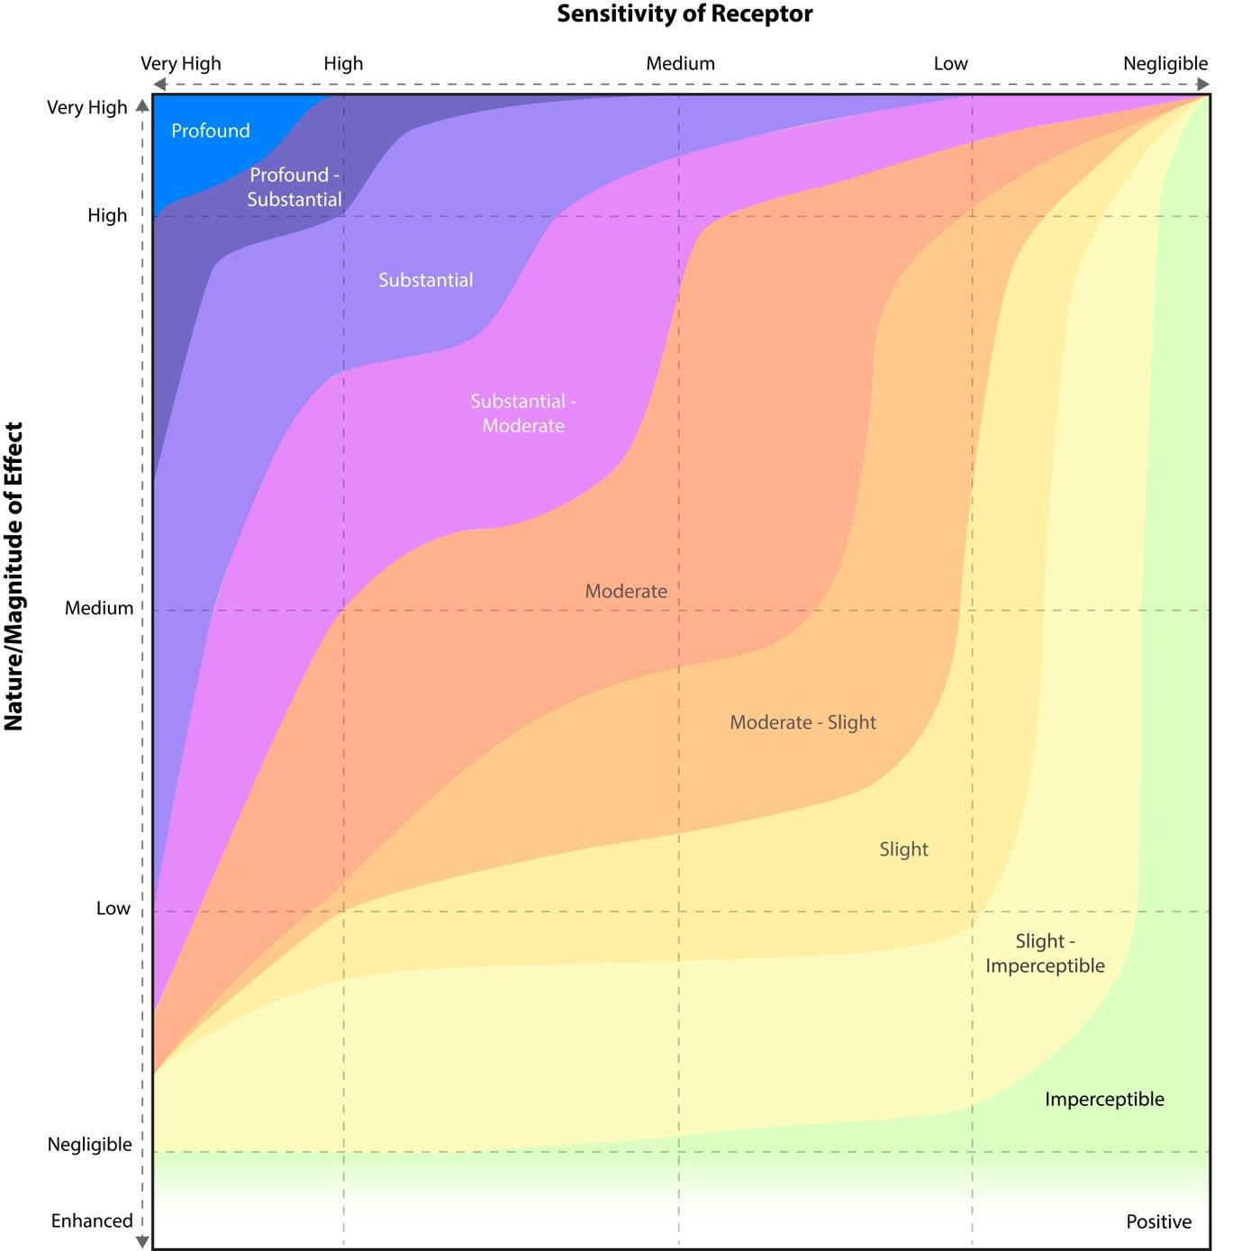
Figure 14 - Impact Significance Matrix

Magnitude | Typical Criteria for Landscape Receptors
High | Major removal or addition of landscape features or removal of localised but unusual or distinctive landscape features and/or addition of new conspicuous features and elements which may alter the character of the landscape (with uncharacteristic features being negative and characteristic features being positive). Physical loss of landscape features that are not replaceable or are replaceable only in the long term.
Medium | Moderate removal or addition of landscape features and/or addition of new noticeable features and elements which would be clearly visible but would not alter the overall character of the landscape (with uncharacteristic features being negative and characteristic features being positive). Physical loss of landscape features that are replaceable in the medium term.
Low | Minor removal or addition of landscape features and/or addition of new discrete features and elements which would be perceptible within but would not alter the overall character of the landscape (with uncharacteristic features being negative and characteristic features being positive). Physical loss of landscape features that are readily replaceable in the short term.
Negligible | Barely perceptible removal or addition of landscape features would occur, and the development would be barely perceptible in visual/ character terms.

9.0 Visual Selector Interaction
The 10 no. visual receptors have been assessed and presented to the design team. Through a process of dialogue in conjunction with the project architects, planners and Digital Dimensions, they represent the most significant and sensitive location points, and were based upon the sensitivity of the locations and typical criteria is listed on Table 4, below.

9.1 Sensitivity – susceptibility of receptors
A visual receptor is a human user of the landscape. The practice has adopted the principle that the sensitivity for each type of visual receptor is inherent to the nature of the activity they are undertaking rather than the view itself.

In accordance with the Institute of Environmental Management and Assessment (“IEMA”) Guidelines for Landscape and Visual Assessment (3rd edition 2013) visual receptors most susceptible to changes in views and visual amenity are:
- “Residents at home
- People, whether residents or visitors, who are engaged in outdoor recreation, including use of public rights of way, whose attention or interest is likely to be focussed on the landscape and on particular views
- Visitors to heritage assets, or to other attractions, where views of the surroundings are an important contributor to the experience
- Communities where views contribute to the landscape setting enjoyed by residents in the area
- Travellers on road rail or other transport routes where such travel involves recognised scenic routes and awareness of views is likely to be heightened”

Visual receptors that are less susceptible to changes in views and visual amenity include:

- “People engaged in outdoor sport or recreation, which does not involve or depend upon appreciation of views of the landscape
- People at their place of work whose attention may be focussed on their work or activity, not their surroundings and where the setting is not important to the quality of working life”

9.2 Images and Photomontages
A collection of 10 no. photomontages have been prepared surrounding the site to fully illustrate the physical and visual nature of the proposed development. Please note the proposed photomontage photo location points were prepared by Digital Dimensions from publicly accessible viewpoints around the location of the subject lands.

Sensitivity | Typical Criteria for Visual Receptors
High | Users of residential properties, public rights of way, named viewpoints and scenic roads or railways.  Users of cultural heritage features including World Heritage Sites, Registered  Parks and Gardens, Scheduled Monuments, Listed Buildings and Conservation Areas where they are known to be tourist destinations or places used by local communities.
Medium | Users of public rights of way (urban or industrial areas) play areas, sporting and outdoor active recreational facilities and rural roads.
Low | Users of office and employment areas, industrial areas and the main road and rail network.
Table 3 - Visual Receptor Sensitivity

10.0 VIA Viewpoints
We have noted images from various receptor points as per the aerial plan (Fig. 15), enclosed in the accompanying landscape receptor views. They have been prepared to illustrate the impacts, if any, with respect to the proposed development along associated access roads.
View | Description
1 | Looking northwest from Rural Road south of subject site
2 | Looking northwest from Rural Road south of subject site
3 | Looking northeast from R135 south of subject site
4 | Looking southeast from R130, at Coolquay Lodge
5 | Looking southeast from R130
6 | Looking southeast from R130
7 | Looking southeast from R130
8 | Looking southeast from R130, at entrance to the proposed developments entrance
9 | Looking south from R130
10 | Looking southwest from Rural Road North of subject site
Table 4 - VIA Viewpoints
The 10 no. visual receptors that are presented, are the closest to the proposed development site and have been selected to best represent the most significant and sensitive location points.

View 1
Existing View | Looking northwest from Rural Road south of subject site
Proposed View | The proposed development shall partly be seen from the rural road and can partly not be seen (red outline) from the road due to the existing planting & hedgerow  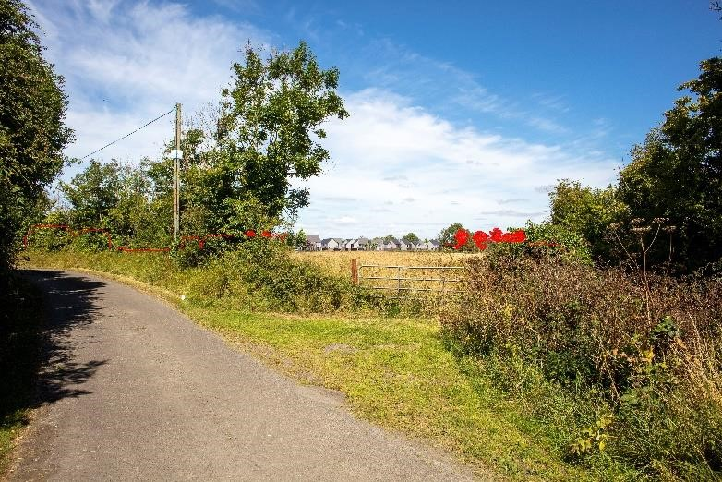
Impact  Construction Stage | Moderate Impact
Impact  Operational Stage | Moderate Impact
Visual Receptor Sensitivity | Medium
Magnitude of Change for Landscape Receptors | Medium
Quality of Change | Moderate to Neutral in the long term
View 2
Existing View | Looking northwest from Rural Road south of subject site
Proposed View | 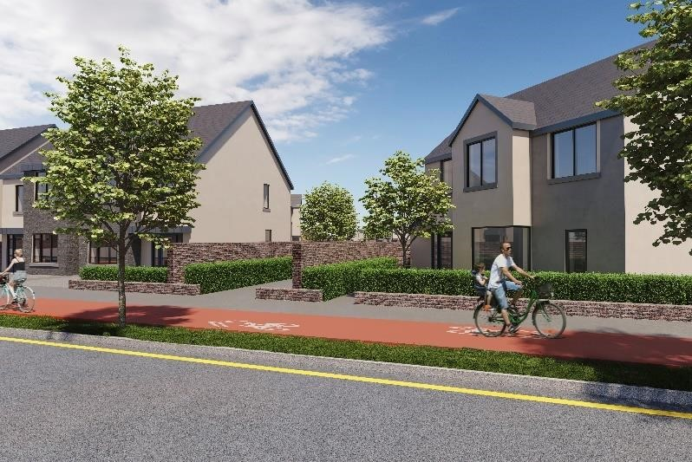  The proposed development may be seen clearly.
Impact  Construction Stage | Negative Impact
Impact  Operational Stage | Moderate Impact
Visual Receptor Sensitivity | Medium
Magnitude of Change for Landscape Receptors | Medium
Quality of Change | Negative short term, Moderate to the medium-term Neutral in the long term

View 3
Existing View | Looking northeast from R135 south of subject site
Proposed View | The proposed development may be seen clearly in the background on the Photomontage, partially blocked by existing and proposed planting.  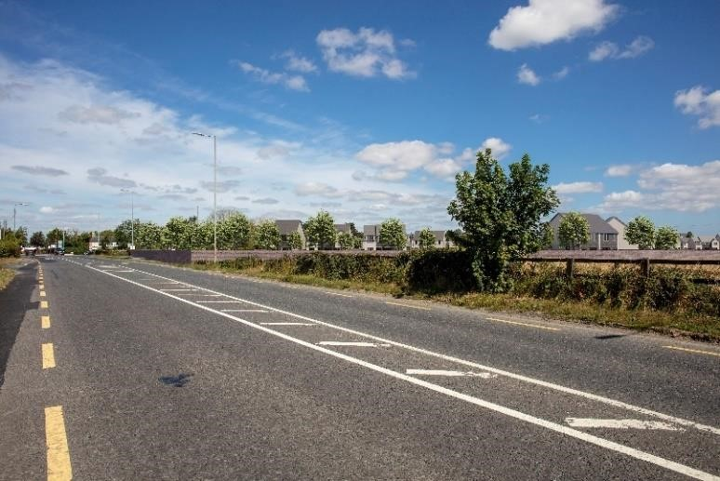
Impact  Construction Stage | Moderate to Negative Impact
Impact  Operational Stage | Moderate Impact
Visual Receptor Sensitivity | Medium
Magnitude of Change for Landscape Receptors | Medium
Quality of Change | Neutral in the long term. Impact reduced over time by maturing plant material – trees, hedges and shrubs.
View 4
Existing View | Looking southeast from R130, at Coolquay Lodge
Proposed View | 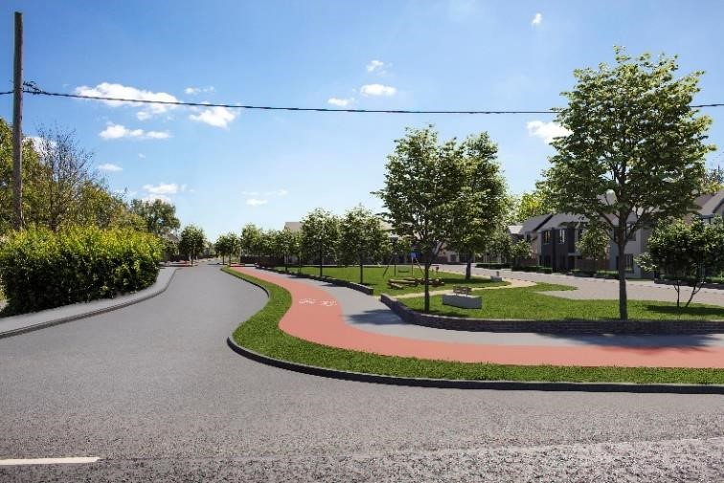  The entrance to the proposed development may be seen clearly.
Impact  Construction Stage | Negative Impact
Impact  Operational Stage | Moderate Impact
Visual Receptor Sensitivity | Medium
Magnitude of Change for Landscape Receptors | Medium
Quality of Change | Negative short term, Moderate to the medium-term Neutral in the long term

View 5
Existing View | Looking southeast from R130
Proposed View | The main part of the proposed development cannot be seen from the road due to the existing mature hedgerow.  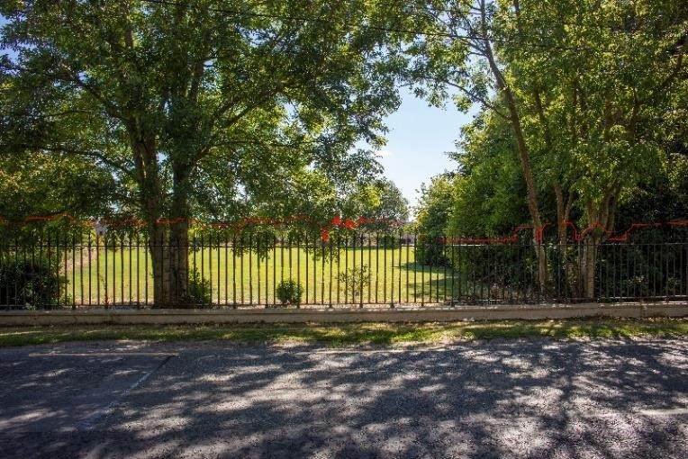
Impact  Construction Stage | Moderate Impact
Impact  Operational Stage | Moderate Impact
Visual Receptor Sensitivity | Medium
Magnitude of Change for Landscape Receptors | Medium
Quality of Change | Neutral in the long term
View 6
Existing View | Looking southeast from R130
Proposed View | 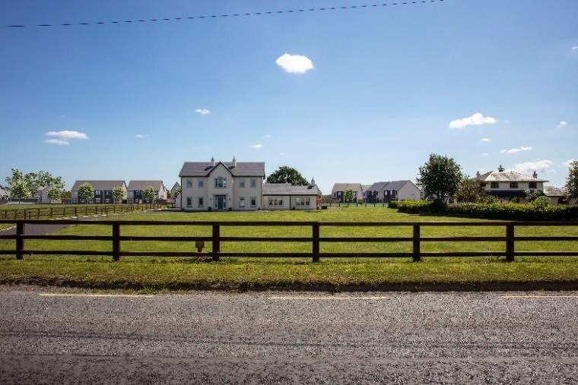  The proposed Development may be seen clearly in the background on the Photomontage, partially blocked by existing dwellings.
Impact  Construction Stage | Moderate to Negative Impact
Impact  Operational Stage | Moderate
Visual Receptor Sensitivity | Medium
Magnitude of Change for Landscape Receptors | Medium
Quality of Change | Negative short term, Moderate to the medium-term Neutral in the long term

View 7
Existing View | Looking southeast from R130
Proposed View | The proposed Development may be seen clearly in the background on the Photomontage, partially blocked by existing dwellings  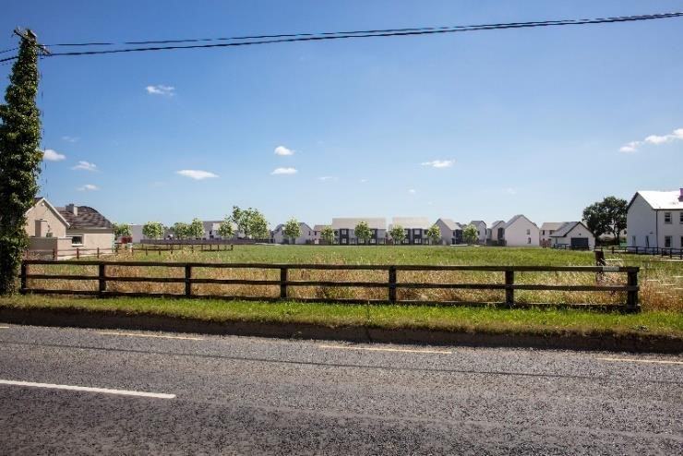
Impact  Construction Stage | Moderate to Negative Impact
Impact  Operational Stage | Moderate
Visual Receptor Sensitivity | Medium
Magnitude of Change for Landscape Receptors | Medium
Quality of Change | Negative short term, Moderate to the medium-term Neutral in the long term
View 8
Existing View | Looking southeast from R130, at entrance to the proposed developments entrance
Proposed View | 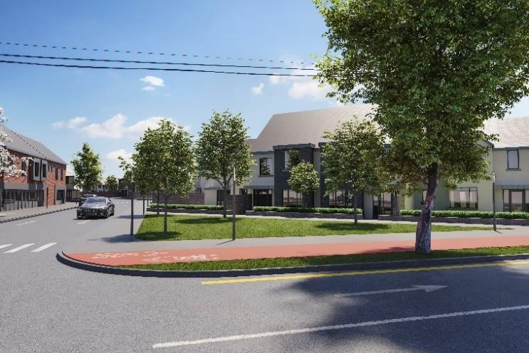  The entrance to the proposed development may be seen clearly.
Impact  Construction Stage | Negative Impact
Impact  Operational Stage | Moderate Impact
Visual Receptor Sensitivity | Medium
Magnitude of Change for Landscape Receptors | Medium
Quality of Change | Negative short term, Moderate to the medium-term Neutral in the long term

View 9
Existing View | Looking south from R130
Proposed View | The proposed development shall partly be seen from the R130. The main part of the proposed development cannot be seen from the road due to the existing mature hedgerow.  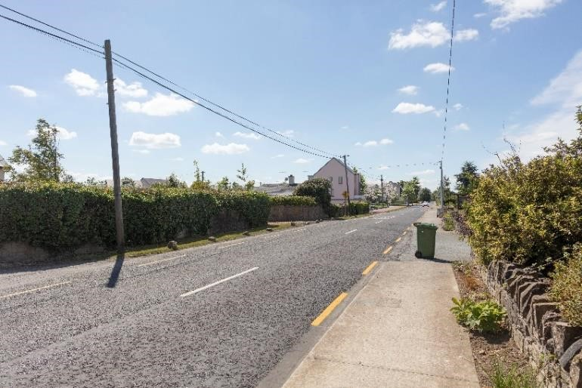
Impact  Construction Stage | Moderate to Negative Impact
Impact  Operational Stage | Moderate Impact – consistent with emerging trends.
Visual Receptor Sensitivity | Low
Magnitude of Change for Landscape Receptors | Low
Quality of Change | Moderate to Neutral in the long term
View 10
Existing View | Looking southwest from Rural Road North of subject site
Proposed View | 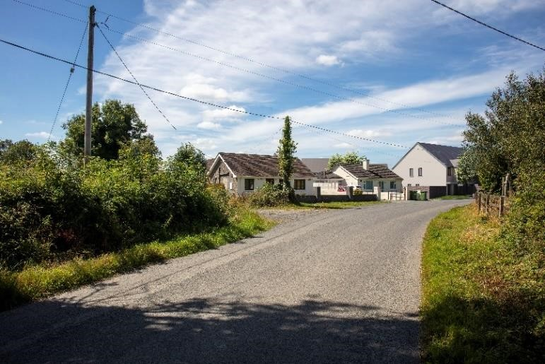  The proposed development shall partly be seen from the R130. The main part of the proposed development cannot be seen from the road due to the existing mature hedgerow.
Impact  Construction Stage | Moderate to Negative Impact
Impact  Operational Stage | Moderate Impact – consistent with emerging trends.
Visual Receptor Sensitivity | Low
Magnitude of Change for Landscape Receptors | Low
Quality of Change | Moderate to Neutral in the long term

11.0 Difficulties Encountered in Compiling
Baldoyle is an open site with easy access to the site. There were no difficulties encountered on visiting the development area.

12.0 Conclusion
As the subject site provides more accommodation for future residents, the well-designed layout that retains and is sympathetic to the characteristics of the surrounding landscape, it shall have a moderate visual impact that is consistent with emerging trends although the visual impact of the shall be negative at first, due to the reduction in open space.
The increase and coherent design of external spaces shall replace the open space of the field. Direct connections to the open space shall provide a positive visual amenity. The retention of the majority of existing native hedgerows, along with the proposed planting shall tie the proposed dwellings with the natural landscape.
Although the character of the environment shall change, it is in line with emerging patterns of development in the locality. The proposal is, however, sympathetic to the surrounding landscape and shall present a moderate visual impact in the long term.
The increased tree cover shall also enhance and increase the biodiversity of the existing landscape and tie it in with the existing hedgerows and trees. It may be viewed, that as this new development retains elements of the area’s existing character, it enshrines the retention of the main internal hedgerow, provides valuable amenity space and creates high quality pedestrian/cycle link to the amenity. As the proposed houses are surrounded by existing hedgerows and housing developments, the visual impact upon the landscape, may not be seen from some of the surrounding visual receptors, the visual impact shall be neutral in the long term.
The proposed development shall provide a coherent ordering of buildings and external spaces and present a positive visual impact upon the existing development and shall not detract from the local landscape. Therefore, the visual impact upon the nature of the landscape shall be moderate to significant in the short term, moderate in the medium term resulting as neutral visual impact in the long term. This shall be due to the emerging patterns of development – maturing landscape and the retention of existing habitat and hedgerows.

13.0 References
- British Standard BS5837:2012 Trees in Relation to Design, Demolition and Construction. Recommendations.
- Advice Notes on Current Practice in the preparation of Environmental Impact Statements (1995)
- Guidelines on the Information to the Contained in Environmental Impact Statements (2002).
- Revised Guidelines on the information to be contained in Environmental Impact Statements Draft (September 2015)
- Advice Notes for Preparing Environmental Impact Statements Draft (September 2015)
- Guidelines On the Information to Be Contained In Environmental Impact Assessment Reports Draft (August 2017)
- Landscape Institute and Institute of Environmental Management & Assessment (2013).
Guidelines for Landscape and Visual Impact Assessment.
- Planning and Development, Act 2000, as amended.
- Fingal County Development Plan 2017 - 2023

